LRPCNS Nursery School Program Offerings
When selecting the schedule for your child please be aware of the offerings available in our program. The programs listed below are scheduled into our regular school day. Enrichment and Lunch Bunch extend beyond the school day and involve extra fees.
Monday - Yoga is offered 2x a month on Monday. It is a half hour per age group.
Thursday and Friday– Music is offered 2x a month on Thursday and Friday, a ½ hour program for each age group.
Fiesta Friday – Spanish, each class will have a ½ hour Spanish program, 2x a month. It will be theme based related to the topic of study in class and age appropriate.

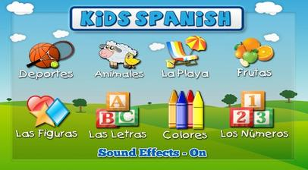
Please turn over
The following programs are offered, but are not incorporated into the school day and involve extra fees.

Tuesday and Wednesday - Lunch Bunch is offered Tuesday and Wednesday. If your child is registered in the 3-year-old program or the 4-year-old program, there is an option to stay until 1:00. There is an extra fee for the additional hour and a family is billed for the extra days at the end of each month.
Monday through Friday – extended day is offered in the 2 ½ -year-old class until 12:00 noon.
Thursday – Enrichment programs are offered in the winter and spring after our regular school hours. Enrichment is dependent on level of interest as we must have a minimum number of students. The programs would begin at 12:15 and would conclude at 2:30. This would be available to all 3s and 4s and would run in 6 week sessions. Different themes would be explored, often science based. This option would be available if your child does attend on Thursdays, but if they do not, they would be able to participate starting at 12:15.
Please note we will offer an early drop off option starting at 8:15 in the morning. This would also include an extra fee. If you are interested, please let us know.
Please contact me with any questions.

